Documentation for MEECC_V.1 – Dashboard Application

1. Introduction
MEECC_V.1 is an analytical model that is run using an interactive web-based tool developed using the Dash framework in Python. Based on a set of user inputs to the model calculates the required level of mitigation efforts corresponding to a range of temperature targets.
The model includes 179 countries clustered in five groups G1 to G5. The model also provides results for country groups by categories classified as Annex-I and non-Annex-I parties as per the classification of the United Nations Framework Convention on Climate Change (UNFCCC). The list of countries included is given in Table 1.

1.1. Dashboard Layout
The layout of the MEECC_V.1 dashboard is organized into three main sections. At the top, the application displays a title: “Model for Energy Equity and Climate Compatibility_Version.1 (MEECC_V.1)”. Below this, the main interface is divided horizontally into two panes. As shown in Figure 1, the left pane consists of three tabs: “Clustering Method”, where users can select any one of the six clustering options using radio buttons; “Countries/Group”, which provides a scrollable checklist for selecting either individual countries or groups; and “Developmental Scenarios”, which includes multiple dropdowns to choose GDP growth, energy thresholds, convergence year, CO₂-LULUCF assumptions, carbon budget allocation, and temperature targets. The right pane displays the graph of the multiple output variables selected from the “Select the Figure to Display” dropdown (see Figure 1). As shown in Figure 2, the bottom section presents two side-by-side panels: on the left, a graph of selected variable details controlled by the “Selected Variable Details” dropdown, and on the right, a data table displaying numerical values corresponding to the main figure. The entire layout uses simple styling to ensure a clean, user-friendly presentation across all devices.
The dashboard code consists of the following sections:
- Loading the Database and Country Clustering
- Scenario Inputs
- Initialisation of the app using dash application and call back
- Outputs
- Auto Launch of the dashboard
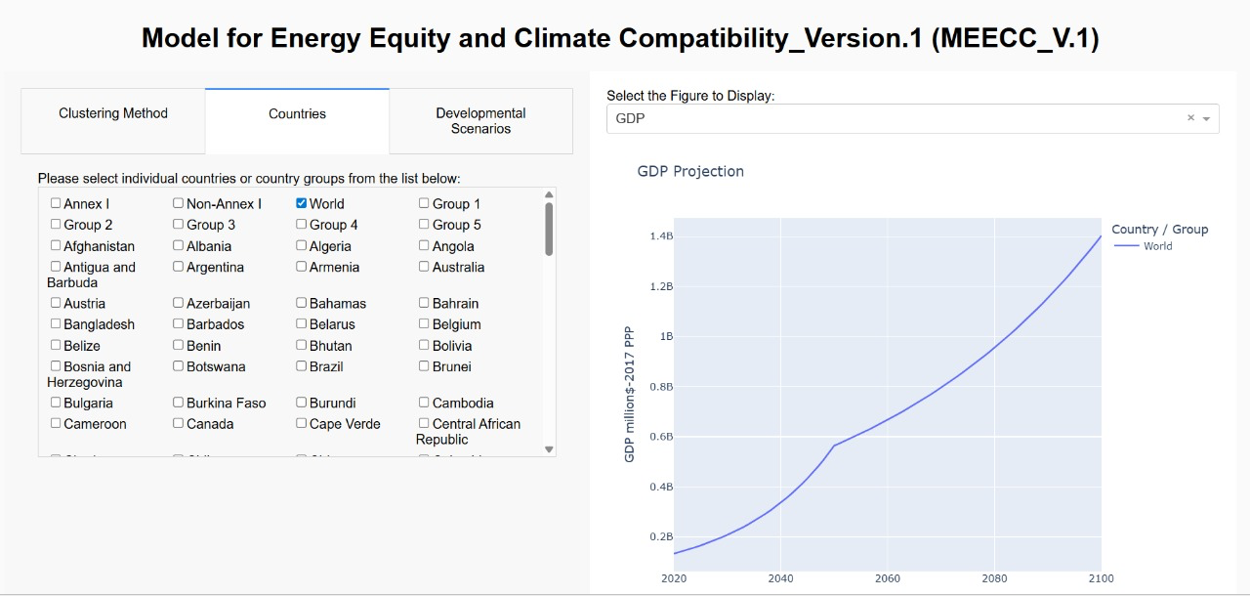

Figure 1. Right and left pane at the top of the dashboard
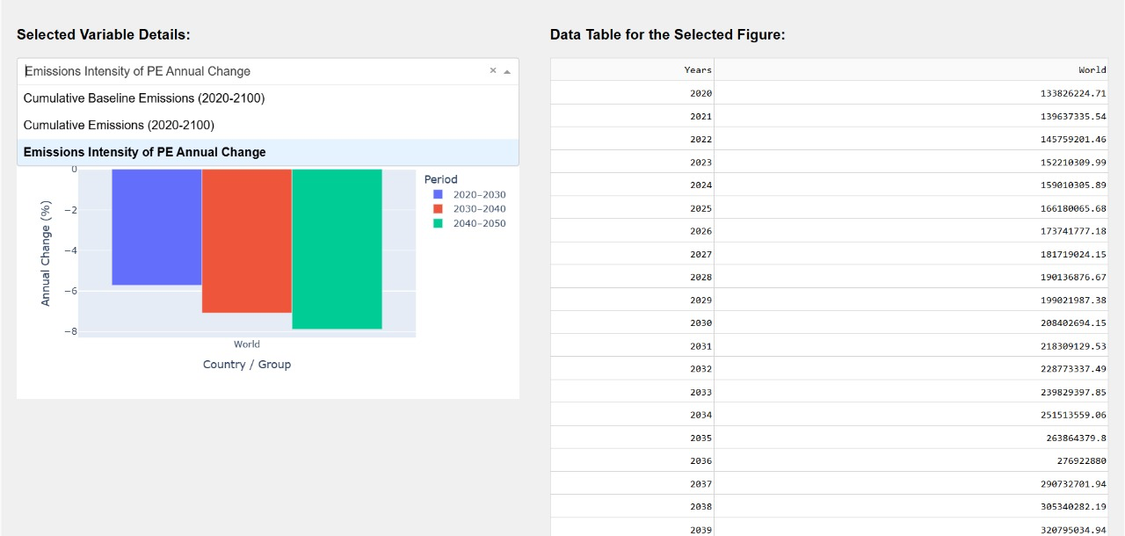

Figure 2. Right and left panels at the bottom of the dashboard

Table 1. List of Countries and Groups Modelled in MEECC_V.1
1 | Afghanistan | 28 | Cambodia | 56 | Fiji | 81 | Jamaica | 107 | Pakistan | 135 | Saint Kitts and Nevis | 158 | Tajikistan
2 | Albania | 29 | Cameroon | 57 | Finland | 82 | Japan | 108 | Panama | 136 | Saint Lucia | 159 | Tanzania
3 | Algeria | 30 | Canada | 58 | France | 83 | Jordan | 109 | Papua New Guinea | 137 | Saint Vincent and the Grenadines | 160 | Thailand
4 | Angola | 31 | Cape Verde | 59 | Gabon | 84 | Kazakhstan | 110 | Paraguay | 138 | Samoa | 161 | Togo
5 | Antigua and Barbuda | 32 | Central African Republic | 60 | Gambia | 85 | Kenya | 111 | Peru | 139 | Sao Tome and Principe | 162 | Tonga
6 | Argentina | 33 | Chad | 61 | Georgia | 86 | Kiribati | 112 | Philippines | 140 | Saudi Arabia | 163 | Trinidad and Tobago
7 | Armenia | 34 | Chile | 62 | Germany | 87 | Kuwait | 113 | Poland | 141 | Senegal | 164 | Tunisia
8 | Australia | 35 | China | 63 | Ghana | 88 | Kyrgyzstan | 114 | Portugal | 142 | Serbia | 165 | Turkey
9 | Austria | 36 | Colombia | 64 | Greece | 89 | Laos | 115 | Qatar | 143 | Seychelles | 166 | Turkmenistan
10 | Azerbaijan | 37 | Comoros | 65 | Grenada | 90 | Latvia | 116 | Romania | 144 | Sierra Leone | 167 | Uganda
11 | Bahamas | 38 | Congo | 66 | Guatemala | 91 | Lebanon | 117 | Russia | 145 | Singapore | 168 | Ukraine
12 | Bahrain | 39 | Costa Rica | 67 | Guinea | 92 | Lesotho | 118 | Rwanda | 146 | Slovakia | 169 | United Arab Emirates
13 | Bangladesh | 40 | Cote d'Ivoire | 68 | Guinea-Bissau | 93 | Liberia | 119 | Madagascar | 147 | Slovenia | 170 | United Kingdom
14 | Barbados | 41 | Croatia | 69 | Guyana | 94 | Libya | 120 | Malawi | 148 | Solomon Islands | 171 | United States
15 | Belarus | 42 | Cuba | 70 | Haiti | 95 | Lithuania | 121 | Malaysia | 149 | Somalia | 172 | Uruguay
16 | Belgium | 43 | Cyprus | 71 | Honduras | 96 | Luxembourg | 122 | Maldives | 150 | South Africa | 173 | Uzbekistan
17 | Belize | 44 | Czechia | 72 | Hungary | 97 | Namibia | 123 | Mali | 151 | South Korea | 174 | Vanuatu
18 | Benin | 45 | Democratic Republic of Congo | 73 | Iceland | 98 | Nepal | 124 | Malta | 152 | Spain | 175 | Venezuela
19 | Bhutan | 46 | Denmark | 74 | India | 99 | Netherlands | 125 | Mauritania | 153 | Sri Lanka | 176 | Vietnam
20 | Bolivia | 47 | Djibouti | 75 | Indonesia | 100 | New Zealand | 126 | Mauritius | 154 | Sudan | 177 | Yemen
21 | Bosnia and Herzegovina | 48 | Dominica | 76 | Iran | 101 | Nicaragua | 127 | Mexico | 155 | Suriname | 178 | Zambia
22 | Botswana | 49 | Dominican Republic | 77 | Iraq | 102 | Niger | 128 | Micronesia (country) | 156 | Sweden | 179 | Zimbabwe
23 | Brazil | 50 | Ecuador | 78 | Ireland | 103 | Nigeria | 129 | Moldova | 157 | Switzerland |  | Annex-I
24 | Brunei | 51 | Egypt | 79 | Israel | 104 | North Macedonia | 130 | Mongolia |  |  |  | Non-Annex-I
25 | Bulgaria | 52 | El Salvador | 80 | Italy | 105 | Norway | 131 | Montenegro
26 | Burkina Faso | 53 | Equatorial Guinea |  |  | 106 | Oman | 132 | Morocco
27 | Burundi | 54 | Estonia |  |  |  |  | 133 | Mozambique
 |  | 55 | Ethiopia |  |  |  |  | 134 | Myanmar

2. Loading the Database and Country Clustering
The excel file “Parent_sheet.xlsx” in MEECC_V.1_revision.zip contains data for the base year, which is 2019 in MEECC_V.1. For variables to which data for year 2019 is not available, the latest available data is used. The data is cleaned and has undergone a gap-filling exercise. Columns A to E contains the names of countries, ISO 3166 code, Latitude, Longitude, and Annex I /Non-Annex I type of the country, respectively. Columns F to L contain data for or up to the base year for each country for key decision variables used in the analysis, i.e. Population (POP), Primary energy consumption (PE), Gross Domestic Product (GDP), CO2 emissions from fossil fuel use and industry (CO2-FFI), CO2 emissions from land use and land use change and forestry (CO2-LULUCF), Cumulative CO2-FFI emissions (CCO2-FFI), and Cumulative CO2-LULUCF emissions (CCO2-LULUCF).
Columns M to AB contain data for the base year for variables used for country classification. The list of decision and clustering variables in “Parent_sheet.xlsx” is given in Table 2, along with the year for which data is provided and units. The column names of the decision and clustering variables in the “Parent_sheet.xlsx” are in the format: “variable name_base year_units” The “Population.csv” provides population projections from the year 2020 to year 2100. The variable POP is exogenous in MEECC_V.1.

Country Clustering
MEECC_V.1. allows 6 different ways of country classification currently. Country classification into developmental groups G1 to G5 can be based on criteria chosen by the users. Users can select the method they want to use from the drop-down menu in the Tab1 of the left pane of the dashboard (see Figure 3). Each method, corresponding to the option selected by the user is explained in Table 3.
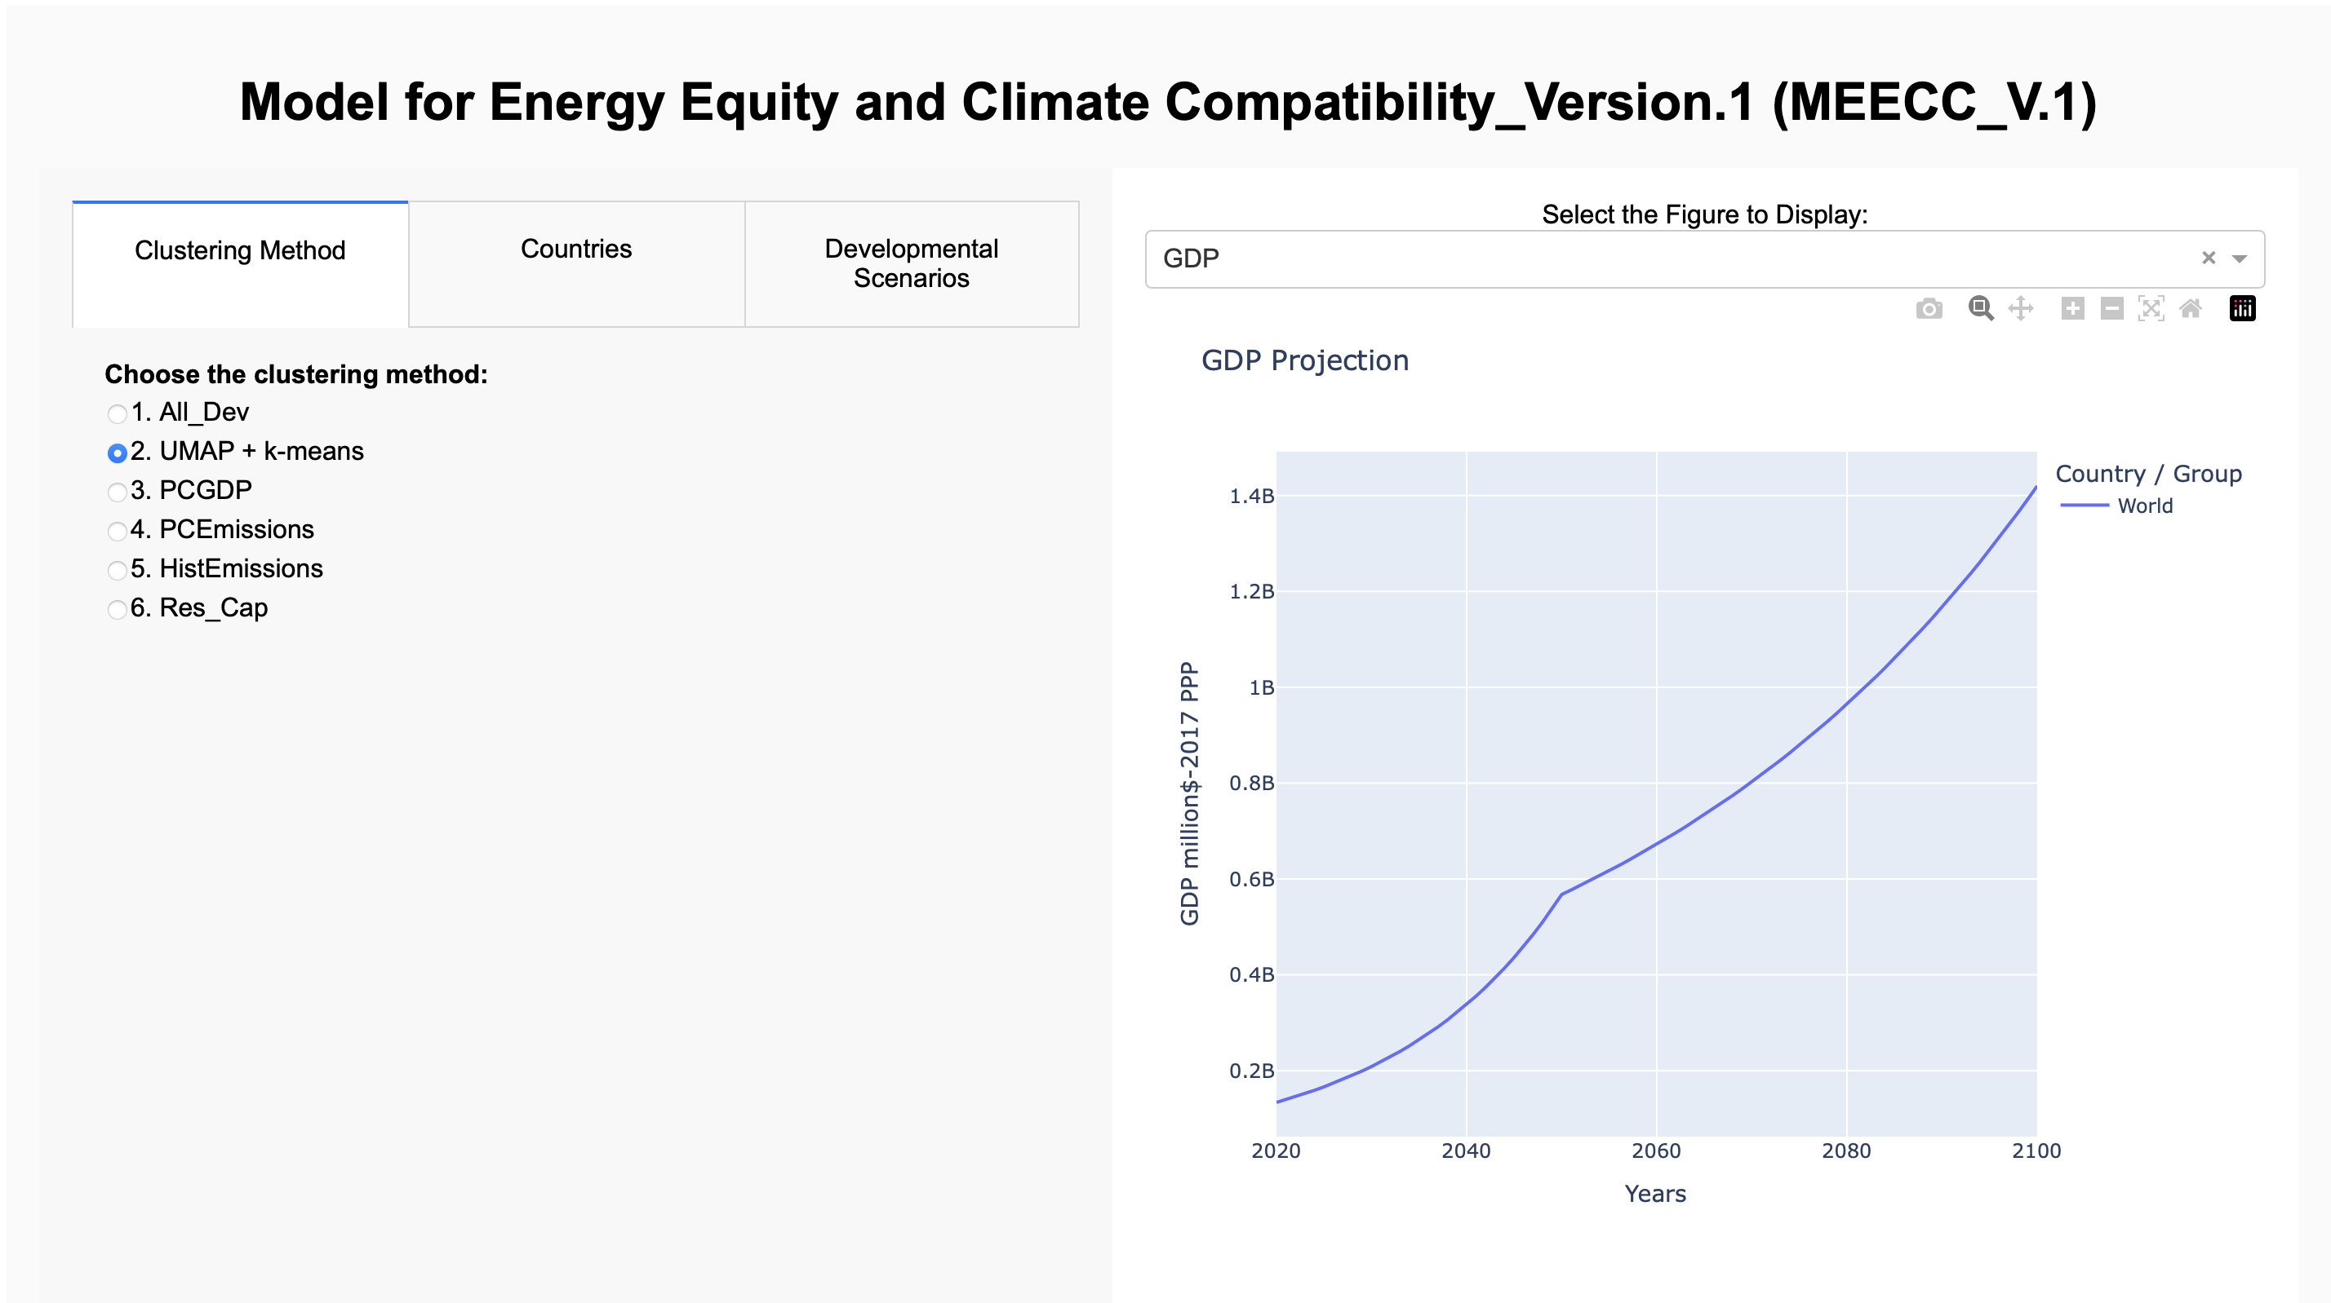
Figure 3. Screenshot of the Dashboard showing the country classification option
Table 2. List of decision variables and variables used in country classification
Variable | Variable name | Base Year | Units | Variable Type
Population | POP | 2019 | No. | Decision variable
Primary energy consumption (EJ) | PE | 2019 | EJ | Decision variable
Gross Domestic Product | GDP | 2019 | $-2017 PPP | Decision variable
CO2 Emissions -FFI | CO2-FFI | 2019 | GtCO2 | Decision variable
CO2 Emissions -LULUCF | CO2-LULUCF | 2019 | GtCO2 | Decision variable
Cumulative CO2 Emissions -FFI | CCO2-FFI | 1850-2019 | GtCO2 | Decision variable
Cumulative CO2 Emissions - LULUCF | CO2-LULUCF | 1850-2019 | GtCO2 | Decision variable
Per capita GDP | PCGDP | 2019 | $/perons -2017PPP | Clustering Variable
Per capita primary energy consumption | PPE | 2019 | GJ/p | Clustering Variable
Access to Electricity | ELEC | 2019 | % | Clustering Variable
Access to Clean Cooking Fuels | CCF | 2019 | % | Clustering Variable
Life expectancy at birth | LEX | 2019 | years | Clustering Variable
Infant mortality rate | IMR | 2019 | Deaths per 100 live births | Clustering Variable
Maternal Mortality Ratio | MMR | 2017 | Women dealths per 100,000 live births | Clustering Variable
Share of deaths from Air Pollution | DAP | 2019 | % | Clustering Variable
Daily Calorific Intake | DAC | 2018 | kcal/p/day | Clustering Variable
Mean years of schooling | MYS | 2019 | years | Clustering Variable
Access to Internet | IAC | 2019 | % | Clustering Variable
Deaths due to unsafe sanitation | DUS | 2019 | deaths/100,000 people | Clustering Variable
Share of the urban population living in slums | PLS | 2018 | % of urban population | Clustering Variable
Death rate from unsafe water sources | DUW | 2019 | Deaths per 100,000 people | Clustering Variable
Per capita CO2-FFI | PCO2-FFI | 2019 | tCO2/person | Clustering Variable
Distance from fair share of cumulative CO2-FFI | CCO2-FF1_DFS | 2019 | GtCO2 | Clustering Variable

Table 3. Options for country classification
User Option | Basis for Classification | Description
PCGDP | Income | Countries are classified based on per capita GDP for year 2019
PCEmissions | Per capita emissions | Countries are classified based on per capita CO2-FFI emissions in year 2019
HistEmissions | Historical Responsibility Based | Countries are classified based on their historical responsibility for past cumulative emissions. This is determined by the difference between their actual emissions and their per capita fair share of the carbon budget between 1850 and 2019
Res_Cap | CBDR&RC | Countries are classified based on a combination of per capita GDP in 2019 (representing current capability) and the difference between their actual emissions and their fair share of the carbon budget between 1850 and 2019 (representing historical responsibility). A combination of weights can be used to assign relative importance to each of these criteria following Holz et. al (2019)
All_Dev | Based on 16 development indicators | Weights can be assigned by users to 16 development variables for income, health, education, infrastructure, energy, and emissions, based on which countries are then classified into development groups.
UMAP+k-means | k-means clustering | Uniform Manifold Approximation and Projection (UMAP), and clustering via the K-Means algorithm. See SI for details.
If the user chooses “Res_Cap” as the method for country classification, currently the weight for ‘Res’ (W^{Res}) and the weight for ‘Cap’ (W^{Cap}) is given equal weighting.
If the user chooses “All_Dev” as the method for country classification, then the weights all developmental variable except W^{PCGDP} are given equal weights. WPCGDP is calculated automatically as the difference between 1 and the sum of all other chosen weights as per equation (1). This is to ensure that the sum of all weights is always equal to 1.
The weighting for the “Res_Cap” and “All_Dev” will be made more customised according to the use preference in the future release of the dashboard.
$W^{PCGDP}+W^{PPE}+W^{ELEC}+W^{CCF}+W^{LEX}+W^{IMR}+W^{MMR}+W^{DAP}+W^{DAC}+W^{MYS}+W^{IAC}+W^{DUS}+W^{PLS}+W^{DUW}+W^{PCO2-FFI}+W^{PCO2-FFI_DFS}=1$ (1)

3. Scenario Inputs
There are six scenario inputs to the MEECC_V.1 model such as GDP, Primary Energy thresholds, year of convergence, CO2-LULUCF emissions, carbon budget allocation, and Temperature target. These options are present in the left pan-Developmental Scenarios tab of the dashboard (see Figure 4).

3.1. GDP Inputs
Users can select the GDP growth scenarios using the GDP Growth drop down menu. The economic growth scenarios available in MEECC_V.1 are listed in Table 4. The rationale behind using exogenous GDP trajectories rather than estimating these based on different combinations of the factors of production, i.e. labour, capital, and energy is given in https://doi.org/10.21203/rs.3.rs-7132898/v1.
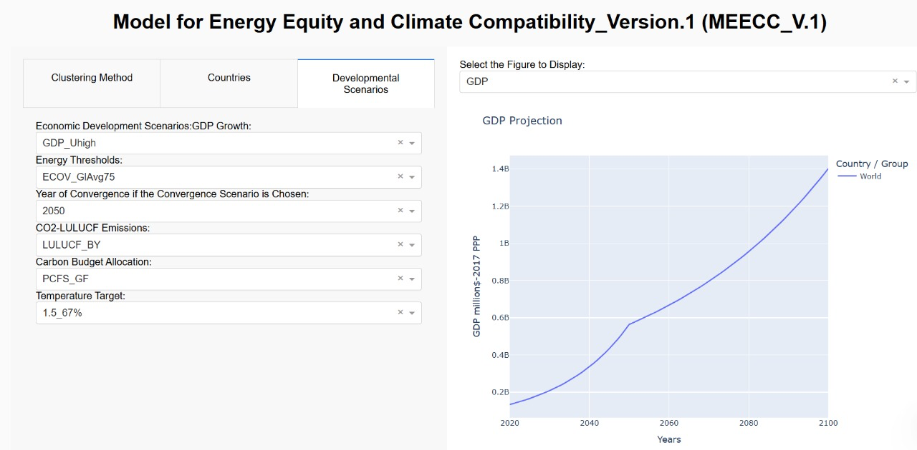
Figure 4: Screenshot of the dashboard showing the scenario inputs options
Table 4. GDP scenarios in MEECC_V.1
Scenario Group | Scenario Name | Description
GDP growth scenarios: GDP growth for all groups with rate of growth progressively increasing from G1 to G5. Higher growth rates at lower levels of development. Post 2050, growth rates of G1, G2, G3, G4, G5 are 0%, 0.5%, 1.5%, 2% and 2.5% for all scenarios. | GDP_UHigh (default) | High growth for all groups resulting in higher global GDP by 2050.GDP of G1, G2, G3, G4, G5 grows at 2%, 4%, 5%, 6% and 7% respectively.
 | GDP_UMed | Medium growth for all groups resulting in moderately high global GDP by 2050.GDP of G1, G2, G3, G4, G5 grows at 1.5%, 3%, 4%, 5%, and 6% respectively
 | GDP_ULow | Low growth for all groups resulting in lower global GDP by 2050.GDP of G1, G2, G3, G4, G5 grows at 1%, 2.5%, 3.5%, 4.5% and 5% respectively
Differentiated GDP Degrowth Scenarios: Reduced or negative growth for G1 and/or G2. Post 2050, growth rates of G1, G2, G3, G4, G5 are 0%, 0.5%, 1.5%, 2% and 2.5% for all scenarios. | GDP_DG1 | GDP of G1, G2, G3, G4, G5 grows at 0%, 3%, 4%,5% and 6% respectively
 | GDP_DG2 | GDP of G1, G2, G3, G4, G5 grows at -1%, 2%, 4%, 5%, and 6% respectively
Threshold Scenarios: A minimum threshold of $28000 for per capita GDP is assumed for all countries. Post-2050, growth rates of G1, G2, G3, G4, G5 are 0%, 0.5%, 1.5%, 2% and 2.5% for all scenarios. | GDP_UMod-TS1 | GDP growth same as GDP_UMed scenario except for countries which do not reach $28,000 per capita GDP till 2050. Higher growth assumed for these countries to achieve threshold
 | GDP_DG2-TS2 | GDP growth same as GDP_DG2 scenario except for countries which do not reach $28,000 per capita GDP till 2050. Higher growth assumed for these countries to achieve threshold

3.2.Energy Inputs
Users can select the method for designing energy scenarios using the Energy Thresholds drop-down menu in the developmental scenarios tab (see Figure 4). Currently only the option for “Threshold_based” energy scenarios are active. Users can also choose to simply determine primary energy consumption by linking it to GDP; this option is not activated in the current version of the MEECC_V.1 model dashboard and will be available in the future releases.
Under the threshold based scenarios, there are currently 2 scenario groups and 8 sub-scenarios from which the users can chose convergence or divergence scenario designs for primary energy consumption. Scenario description is given in Table 5.
If the user chooses any one of the convergence scenario, then the year of convergence can also be selected using “Year of convergence if the convergence scenario” drop down menu.

Table 5. Scenario designs for primary energy consumption in MEECC_V.1
Scenario Group | Scenario Name | Description
Convergence scenarios: Energy convergence to a particular level by 2050, eventual convergence to 70 GJ for all by 2100 | ECOV_GlAvg75 | All groups converge at 75 GJ/p by 2050 and remain at this level beyond 2050
 | ECOV_QPT60 | All groups converge at 60 GJ/p by 2050 and remain at this level beyond 2050
 | ECOV_QPT70 | All groups converge at 70 GJ/p by 2050 and remain at this level beyond 2050
 | ECOV_QPT80 | All groups converge at 80 GJ/p by 2050 and remain at this level beyond 2050
 | ECOV_QPT90 | All groups converge at 90 GJ/p by 2050 and remain at this level beyond 2050
 | ECOV_QPT95 | All groups converge at 95 GJ/p by 2050 and remain at this level beyond 2050
Divergence scenarios: Energy consumption different for different groups, eventual convergence to 70 GJ for all by 2100 | EDIV_High | High divergence: G1 reaches or reduces to 200 GJ by 2050 and then remains at this level; G2 reaches or reduces to 160 GJ and remains at this level; G3 reaches or reduces to 55 GJ and then remains at this level; G4 reaches or reduces to 30 GJ and then remains at this level. G5 reaches or reduces to 15 GJ and then remains at this level
 | EDIV_Med | Medium divergence: G1 reaches or reduces to 160 GJ by 2050 and then remains at this level; G2 reaches or reduces to 120 GJ and remains at this level; G3 reaches or reduces to 75 GJ and then remains at this level; G4 reaches or reduces to 40 GJ and then remains at this level. G5 reaches or reduces to 25 GJ and then remains at this level

3.3. Emissions Inputs
3.3.1. CO2-LULUCF
In MEECC_V.1, CO2-LULUCF emissions follow fixed scenarios. Users can choose the CO2-LULUCF scenario from a set of three choices in the “CO2-LULUCF Emissions” drop-down menu (see Figure 4). The three scenarios for LULUCF that are currently in MEECC_V.1 are shown in Table 6.

Table 6. CO2-LULUCF Scenarios in MEECC_V.1
Scenario Group | Scenario Name | Description
Changes in CO2-LULUCF in the Baseline | LULUCF_BY | Annual LULUCF emissions remain the same as base year, i.e. sources remain sources and sinks remain sinks
Changes in CO2-LULUCF in the Baseline | LULUCF_PartShift | Sinks remain the same in terms of annual emissions as of 2019, sources become net-zero by 2050 and remain at zero thereafter
Changes in CO2-LULUCF in the Baseline | LULUCF_Shift | LULUCF emissions for all regions with positive LULUCF emissions reduce to zero by 2050 and maximum of -0.005 by 2100. Those below -0.005 remain at 2019 levels.
3.3.1. Temperature Target
Users can select the temperature target for which the scenario is to be created from the “Temperature Target” drop-down menu in the developmental Scenarios tab (see Figure 4). The temperature targets currently included in the MEECC_V.1. are given in Table 7.
Table 7. Temperature targets in MEECC_V.1
Scenario Name | Description
1.5_67% | 50% probability of limiting warming to 1.5 deg. C
1.5_50% | 67% probability of limiting warming to 1.5 deg. C
1.7_67% | 67% probability of limiting warming to 1.7 deg. C
1.7_50% | 50% probability of limiting warming to 1.7 deg. C
2_67% | 67% probability of limiting warming to 2 deg. C
2_50% | 50% probability of limiting warming to 2 deg. C
>>2C | over 50 % probability of exceeding 2 deg. C
3.3.2. Carbon Budget Allocation
The next step is to choose the allocation scheme for the carbon budget associated with a temperature target. Users can select the carbon budget allocation scheme from the “Carbon Budget Allocation” drop-down menu (see Figure 4). The options available in MEECC_V.1 for carbon budget allocation schemes are based on equitable and unequitable distribution of the remaining carbon budget (RCB) associated with a chosen temperature target (See Table 8).

Table 8. Carbon Budget Allocation Schemes in MEECC_V.1
Scenario Group | Scenario Name | Description
Equity Based | PCFS_GF | Per capita fair share of the RCB based on 2019 population, not accounting for historical responsibility or respective capability
Equity Based | PCFS_Hist | Per capita fair share of the RCB based on 2019 population, weighted by historical responsibility - weighted by emissions between 1850 and 2019
Equity Based | PCFS_Cap | Per capita fair share of the RCB based on 2019 population, weighted by capability - weighted by per capita GDP in 2019
Equity Based | PCFS_HistCap | Per capita fair share of the RCB based on 2019 population, weighted by responsibility and capability - weighted by per capita GDP in 2019 and historical emissions between 1850 and 2019
Inequity Based | PCUS_CurrAnn | Per capita share of the RCB same as annual share of current (2019) emissions
The PCFS_HistCap option has two indicators that determine the distribution of the carbon budget, which is the historical responsibility indicator (W_{hist}) and the capability’s indicator (W_{cap}). In the current version of the MEECC_V.1, equal weighting is given to W_{hist} and W_{cap}, which will be more customised according to the user preference of weighting in the future releases.

4. Initialisation of Dash App
The dash App is initialised and the layout of the app is designed as mentioned previously in section 1.1.

5. Call Backs
GDP and Energy Projection:
Firstly, the GDP of the selected country is projected from 2020 to 2100 based on the user-selected scenario option for GDP growth as mentioned in section 2.1. For example, if country A belongs to group G1, then the GDP growth rate for that country will be based on the GDP growth rate selected for group G1 in a particular scenario. In the case of ‘Threshold scenarios’ , i.e. scenarios GDP_UMod-TS1 and GDP_DG2-TS2, growth are calculated using equations 2 and 3 respectively.
$if (PC{GDP}_{i,2050}>28,000,{GR}_{GDP_{UMod}}, else{\left(\frac{28,000×{POP}_{i,2050}}{{GDP}_{i,2019}}\right)}^{\left(\frac{1}{\left(2050-2019\right)}\right)}-1$ (2)
$if (PC{GDP}_{i,2050}>28,000,{GR}_{GDP_DG}, else{\left(\frac{28,000×{POP}_{i,2050}}{{GDP}_{i,2019}}\right)}^{\left(\frac{1}{\left(2050-2019\right)}\right)}-1$ (3)
Where, PCGDP_{i} stands for per capita GDP for country i, GRg stands for growth rate for group g based on user selected scenario design.
Secondly, Based on the per capita energy scenario chosen by the user using the “Energy Threshold” drop down menu as mentioned in section 2.2, and current levels of primary energy consumption, growth in energy consumption of the selected country or the group is calculated for each country using equation 4.
${GRE}_{i}={\left(\frac{{PPE}_{i,TY}}{{PPE}_{i,BY}}\right)}^{1/{(TY-BY)}}-1$ (4)
Where GRE_{i} is the growth rate in per capita primary energy consumption for country i. PPE is per capita primary energy consumption and TY and BY are the chosen target year and base year (2019 in MEECC_V.1). The implied primary energy consumption is then calculated as the product of per capita primary energy consumption and population.
Further, Primary energy intensity of GDP is calculated as the ratio of primary energy and GDP for each year between 2020 and 2100. In addition, the decadal changes in the energy intensity of GDP up to 2050 are also calculated for the selected country or the group.
Net CO2 emissions projections:
Initially, the baseline emissions intensity of energy, i.e., the ratio of CO2-FFI emissions to primary energy consumption in the base year 2019 for the selected country is calculated. The baseline CO2-FFI emissions for the country selected are then calculated as a product of primary energy consumption and this baseline emissions intensity of energy (which is kept constant throughout the modelling horizon in the baseline).
Further, based on the user selection for the CO2-LULUCF emissions projection using the “CO2-LULUCF emissions” drop-down menu, CO2 LULUCF emissions are projected from 2020 to 2100 for the selected country. Global CO₂-LULUCF emissions in 2019 are estimated to be about 4.53 GtCO₂ (https://doi.org/10.5281/zenodo.15016289). The land sector is therefore currently a source of GHG emissions at the global level. In the LULUCF_BY scenario, CO₂-LULUCF emissions are assumed to remain at this level through the century, with a cumulative emission of 82 GtCO2 globally from the LULUCF sector between 2020 and 2100. In the LULUCF_PartShift scenario cumulative CO₂-LULUCF emissions between 2020 and 2100 are 42 GtCO2, with annual emissions in 2050 reaching -0.42 GtCO₂ and in the LULUCF_Shift scenario cumulative emissions between 2020 and 2100 are 25.53 GtCO₂ with annual emissions in 2100 reaching -1.72 GtCO₂. The total negative emissions between 2020 and 2100 range between 34-57 GtCO2 across all scenarios currently in the MEECC_V.1.
Finally, Net-CO2 baseline emissions, i.e. net-CO2 emissions without any mitigation are then calculated for the country selected as a sum of CO-FFI emissions in the baseline and the CO2-LULUCF emissions based in the scenario selected by the user.
The final step is to define the year in which emissions peak and start to reduce. In the current version of MEECC_V.1, peaking years are set based on historical responsibility.
The model calculates the peaking year based on the deviations of the countries actual cumulative CO2 emissions between 1850 and 2019 from its fair share for this period. The criteria and default peaking years in this schema are given in Table 9. FS/AS is the ratio between Fair Share and Actual Share of cumulative emissions between 1850 and 2019. The lower the ratio, the higher the historical responsibility. In the future release of MEECC_V.1, the users preference for the method of peak year determination and the options to change the default peaking years in the “Historical Responsibility” method will be enabled.
Table 9. Year for peak emissions based on Historical Responsibility
Ratio of Fair Share to Actual Share of Cumulative Emissions  between 1850 and 2019 | Peak Year Constraints
<0.5 | 2020
>0.5, <1 | 2025
>1, <2 | 2030
>2, <3 | 2035
>3 | 2040
The share of the remaining carbon budget allocated to the selected country is based on the option chosen by the user from the “Carbon Budget Allocation” drop-down menu. While the values of the remaining carbon budget (RCB) used in MEECC_V.1 are from 2020 to the time of global net-zero, they are assumed to correspond to the temperature target irrespective of the timing of net-zero emissions. The list of options available are already discussed in section 3.3.2.
For scenario PCFS_GF (Per capita fair share of the remaining carbon budget based on grandfathering past emissions), the share of the remaining carbon budget (RCB) allocated to a country (AS) is the same as that country’s share in the global population in year 2019 (equation 5).
${AS}_{i}[PCFS_GF]={RCB}^{T}×{POP}_{i}$ (5)
Where RCB^{T} is the remaining carbon budget corresponding to a certain probability of limiting warming to a particular temperature level T, and POP_{i} is the population for country i.
For scenario PCFS_Hist, (per capita fair share based on historical responsibility, i.e. on historical emissions), a country’s share of the RCB is calculated using equation 6.
${AS}_{i}[PCFS_Hist]={RCB}^{T}×\frac{\frac{{POP}_{i}}{\sum_{i}{{POP}_{i}}}×\left(\sum_{i}{{CEM}_{i}^{1850-2019}}-{CEM}_{i}^{1850-2019}\right)}{\sum_{i}{\left\{\frac{{POP}_{i}}{\sum_{i}{{POP}_{i}}}×\left(\sum_{i}{{CEM}_{i}^{1850-2019}}-{CEM}_{i}^{1850-2019}\right)\right\}}}$ (6)
Where CEM_{i} stands for the historical cumulative emissions for country i from year 1850 to 2019.
For scenario PCFS_Cap (per capita fair share based on capability of the country measures in terms of its per capita GDP - PCGDP), a country’s share of the RCB is calculated using equation 7.
${AS}_{i}[PCFS_Cap]={RCB}^{T}×\frac{\frac{{POP}_{i}}{\sum_{i}{{POP}_{i}}}\left(\sum_{i}{{PCGDP}_{i}}-{PCGDP}_{i}\right)}{\sum_{i}{\left\{\frac{{POP}_{i}}{\sum_{i}{{POP}_{i}}}×\left(\sum_{i}{{PCGDP}_{i}}-{PCGDP}_{i}\right)\right\}}}$ (7)
For scenario PCFS_HistCap (per capita fair share weighted by both historical responsibility and capability), a country’s share of the RCB is calculated using equation 8.
${AS}_{i}\left[PCFS_HistCap\right]={RCB}^{T}×\left({AS}_{i}\left[PCFS_Hist\right]×W^{hist}+{AS}_{i}[PCFS_Cap]×W^{Cap}\right)$(8)
Where W^{hist} and W^{cap} are the weights for responsibility (historical emissions) and capability (per capita GDP) respectively. Here, W^{hist} and W^{cap} are given equal weights
For scenario PCUS_CurrAnn (per capita share based on current annual emissions), a country’s share of the RCB is calculated using equation 9.
${AS}_{i}\left[PCUS_{CurrAnn}\right]={RCB}^{T}×\left(\frac{CO2-FFI_{i}+CO2-LULUCF_{i}}{\sum_{i}{\left(CO2-FFI_{i}+CO2-LULUCF_{i}\right)}}\right)$ (9)
Remaining carbon budget (RCB) of the country selected is calculated based on the scenario option chosen by the user in the “Carbon Budget Allocation” drop-down menu.
It is assumed that the country’s emissions will grow till the peaking year based on inputs chosen by the user for GDP growth and energy consumption, assuming a constant emissions intensity of energy till the year of peak emissions. Post peaking, the emissions must reach net-zero such that the total emissions from 2019 till the year of peak emissions, and from the year of peak emissions till the year of net-zero are within the allocated share of the RCB for that country. Given that this is an analytical model, the rate of reduction from the time of peak to the time of net-zero is assumed to be linear in the MEECC_V.1. Based on all of the calculations discussed above, the net-CO2 emissions from meeting certain levels of energy and income levels, and from aligning mitigation efforts to specific temperature levels are arrived.
In addition, per capita net-CO2 emissions, emission intensity of primary energy, the annual change in emissions intensity of energy from 2020-30, 2030-40, 2040-50, and the emissions intensity of GDP for the selected country are then calculated for the selected set of user inputs.
If the groups such as Annex-I, non-Annex-I, G1, G2, G3, G4, G5, and the world are selected by the user, then countries belong to the selected group are processed in a loop, and the results are aggregated appropriately.

6. Outputs
Users have to choose the variable to be displayed from the “Select the variables to display” drop-down menu in the right pane of the page. The graphical results for scenarios based on user inputs for the chosen variables are then displayed (see Figure 1).
Some other variables such as the cumulative baseline CO2 emissions (2020-2100), cumulative CO2 emissions (2020-2100), decadal change in emissions intensity of energy from 2020-30, 2030-40, 2040-50, are visualised as bar charts in the bottom left pane of the page (see Figure 2). The list of output variables available for visualisation are given in Table 10. Also, the bottom right pane displays the numerical values of the main graph selected.
Table 10: List of output variables available for visualisation
Variable | Units | Description
population | number | Population Projection from 2020 to 2100
Primary Energy Consumption | EJ | Primary energy consumption from 2020 to 2100
Baseline CO2-FFI Emissions | GtCO2 | CO2-FFI emissions without mitigation
Baseline Emissions Intensity | GtCO2/EJ | Baseline Net CO2 emissions/GDP
CO2-LULUCF_Chosen Scenario | GtCO2 | CO2-LULUCF emissions based on chosen scenario
Baseline Net CO2 | GtCO2 | Net CO2 (CO2-FFI +CO2 LULUCF) emissions without mitigation
CO2_Net | GtCO2 | Net CO2 emissions (with mitigation)
Emissions Intensity of Primary Energy_Chosen Scenario | GtCO2/EJ | Net CO2 emissions (with mitigation)/Primary energy chosen scenario
GDP | $-2017-PPP | GDP projection (2020-2100)
Per capita GDP | $-2017-PPP | GDP/Population (2020-2100)
Per Capita Net CO2 in Baseline | tCO2 | Net CO2 (without mitigation)/Population (2020-2100)
Per capita Net CO2 | tCO2 | Net CO2 (with mitigation)/Population (2020-2100)
Per capita primary energy consumption | GJ | Primary energy consumption/Population (2020 to 2100)
Primary Energy Intensity of GDP | MJ/$ | Primary energy consumption/GDP (2020-2100)
Cumulative Baseline Emissions _2020-2100 | GtCO2 | Cumulative Net CO2 emission (without mitigation) from 2020 to 2100
Cumulative Emissions_2020-2100 | GtCO2 | Cumulative Net CO2 emission (with mitigation) from 2020 to 2100
Emissions Intensity of PE_Annual Change | % p.a.

7. Auto launch of the Application
The MEECC_V.1 dashboard includes an auto-launch feature that opens the application in the default web browser automatically, using any available port. This is built into the main Python script and works across platforms. To make it even easier for non-technical users, launcher scripts (run_dashboard.bat for Windows and run.sh for Mac/Linux) are provided, so the dashboard can be started with a simple double-click or terminal command.

